**WEB TECHNOLOGY**

**Lab Assignment 1**

**Name: Atharva Kavade**

**Div: SY-AIDS-B**

**Roll No.: 12**

**PRN No: 12310269**

**HTML code**

**Main.html**

<!DOCTYPE html>

<html lang="en">

<head>

    <meta charset="UTF-8">

    <meta name="viewport" content="width=device-width, initial-scale=1.0">

    <title>Tesla Clone - Dark Mode</title>

    <link rel="stylesheet" href="styles.css">

</head>

<body>

    <header class="header">

        <div class="logo"><img

                src="https://upload.wikimedia.org/wikipedia/commons/thumb/e/e8/Tesla_logo.png/900px-Tesla_logo.png"

                alt="Tesla Logo"></div>

        <nav class="nav">

            <a href="#model-s">Model S</a>

            <a href="#model-3">Model 3</a>

            <a href="#model-x">Model X</a>

            <a href="#model-y">Model Y</a>

        </nav>

        <nav class="nav right">

            <a href="#">Shop</a>

            <a href="charging.html">Charging</a>

            <a href="#" class="menu">Menu</a>

        </nav>

    </header>

    <main>

        <section class="video-section">

            <video autoplay muted loop>

                <source src="videoplayback.mp4" type="video/mp4">

                Your browser does not support the video tag.

            </video>

        </section>

        <section class="hero" id="model-s">

            <div class="overlay">

                <h1>Model S</h1>

                <p>Plaid</p>

                <button>Order Now</button>

            </div>

        </section>

        <section class="hero" id="model-3">

            <div class="overlay">

                <h1>Model 3</h1>

                <p>Order Online for Touchless Delivery</p>

                <button>Order Now</button>

            </div>

        </section>

        <section class="hero" id="model-x">

            <div class="overlay">

                <h1>Model X</h1>

                <p>Plaid</p>

                <button>Order Now</button>

            </div>

        </section>

        <section class="hero" id="model-y">

            <div class="overlay">

                <h1>Model Y</h1>

                <p>Order Online for Touchless Delivery</p>

                <button>Order Now</button>

            </div>

        </section>

    </main>

    <footer class="footer">

        <p>&copy; 2024 Tesla Clone. All rights reserved.</p>

    </footer>

</body>

</html>

**CSS File**

* {

    margin: 0;

    padding: 0;

    box-sizing: border-box;

    font-family: 'Arial', sans-serif;

}

body {

    display: flex;

    flex-direction: column;

    min-height: 100vh;

    background-color: #121212;

    color: #e0e0e0;

}

.header {

    background-color: #1f1f1f;

    display: flex;

    justify-content: space-between;

    align-items: center;

    padding: 20px;

    position: fixed;

    width: 100%;

    top: 0;

    z-index: 1000;

    border-bottom: 1px solid #333;

}

.heading {

    font-weight: bold;

    margin-bottom: 10px;

}

h1.heading {

    font-size: 36px;

    margin-top: 20px;

}

h2.heading {

    font-size: 24px;

    margin-top: 20px;

}

.logo img {

    height: 50px;

}

.nav {

    display: flex;

    gap: 20px;

}

.nav a {

    color: #e0e0e0;

    text-decoration: none;

    font-size: 16px;

}

.nav a:hover {

    color: #f70606;

}

.nav.right a.menu {

    display: none;

}

.video-section {

    height: 100vh;

    display: flex;

    justify-content: center;

    align-items: center;

    background-color: #000;

    position: relative;

}

.video-section video {

    width: 100%;

    height: 100%;

    object-fit: cover;

}

.hero {

    height: 100vh;

    display: flex;

    justify-content: center;

    align-items: center;

    background-size: cover;

    background-position: center;

    position: relative;

    text-align: center;

}

.hero .overlay {

    background: rgba(0, 0, 0, 0.6);

    padding: 20px;

    border-radius: 10px;

}

#model-s {

    animation: slide 30s infinite;

    background-size: cover;

    background-position: center;

}

*@keyframes* *slide* {

    0% {

        background-image: url('https://imgd-ct.aeplcdn.com/1056x660/n/cw/ec/93821/model-s-exterior-front-view.jpeg?q=80');

    }

    33% {

        background-image: url('https://imgd-ct.aeplcdn.com/1056x660/n/cw/ec/93821/model-s-exterior-right-side-view.jpeg?q=80');

    }

    66% {

        background-image: url('https://imgd-ct.aeplcdn.com/1056x660/n/cw/ec/93821/model-s-exterior-left-rear-three-quarter.jpeg?q=80');

    }

    100% {

        background-image: url('https://imgd-ct.aeplcdn.com/1056x660/n/cw/ec/93821/model-s-exterior-front-view.jpeg?q=80');

    }

}

#model-3 {

    background-image: url('https://i.pinimg.com/736x/e7/5a/08/e75a08f76f57862b0c2b7b7720d24153.jpg');

}

#model-x {

    background-image: url('https://c4.wallpaperflare.com/wallpaper/294/359/763/car-model-tesla-electric-wallpaper-preview.jpg');

}

#model-y {

    background-image: url('https://st4.depositphotos.com/3317865/40476/i/450/depositphotos_404764406-stock-photo-tesla-model-tesla-charger.jpg');

}

button {

    background-color: #333;

    color: #e0e0e0;

    border: none;

    padding: 10px 20px;

    margin-top: 20px;

    cursor: pointer;

    border-radius: 5px;

}

button:hover {

    background-color: #f70606;

}

.footer {

    background-color: #1f1f1f;

    color: #f70606;

    text-align: center;

    padding: 10px;

    margin-top: auto;

    border-top: 1px solid #333;

}

**changing.html**

<!DOCTYPE html>

<html lang="en">

<head>

    <meta charset="UTF-8">

    <meta name="viewport" content="width=device-width, initial-scale=1.0">

    <title>Tesla Charging Stations</title>

    <link rel="stylesheet" href="styles.css">

    <style>

        body {

            display: flex;

            flex-direction: column;

            min-height: 100vh;

            background-color: #121212;

            color: #e0e0e0;

        }

        .heading {

            color: #fb0606;

            font-size: 24px;

            font-weight: bold;

            margin-bottom: 10px;

        }

        .paragraph {

            font-size: 18px;

            margin-bottom: 20px;

        }

        ul,

        ol {

            list-style: none;

            padding: 0;

            margin: 0;

        }

        .list-item {

            font-size: 18px;

            margin-bottom: 10px;

        }

        ul li::before {

            content: "\2022";

            font-weight: bold;

            font-size: 18px;

            color: #333;

            margin-right: 10px;

        }

        ol li::before {

            content: counter(list-item) ". ";

            counter-increment: list-item;

            font-weight: bold;

            font-size: 18px;

            color: #333;

            margin-right: 10px;

        }

        h2 {

            margin-top: 40px;

        }

        .container {

            max-width: 800px;

            margin: 40px auto;

            padding: 20px;

            border: 1px solid #181616;

            border-radius: 10px;

            box-shadow: 0 0 10px rgba(0, 0, 0, 0.1);

            border: 1px solid #ddd;

            box-shadow: 0 0 10px rgba(0, 0, 0, 0.1);

        }

    </style>

</head>

<body>

    <div class="container">

        <h1 class="heading">Tesla Charging Stations</h1>

        <h2 class="heading">About Tesla Charging Stations</h2>

        <p class="paragraph">

            Tesla charging stations are a network of electric vehicle charging stations that are owned and operated by

            Tesla

            Inc. These stations are designed to provide convenient and fast charging for Tesla electric vehicles.

        </p>

        <h2 class="heading">Benefits of Tesla Charging Stations</h2>

        <ul>

            <li class="list-item">Fast Charging: Tesla Superchargers can charge a Tesla vehicle significantly faster

                compared to regular

                charging stations.</li>

            <li class="list-item">Convenience: Tesla charging stations are strategically located along major highways

                and in

                popular

                destinations, making it easy for Tesla owners to plan their trips.</li>

            <li class="list-item">Network Coverage: Tesla has a growing network of charging stations globally, ensuring

                that

                Tesla owners have

                access to charging infrastructure wherever they go.</li>

            <li class="list-item">Integration with Tesla Vehicles: Tesla charging stations are seamlessly integrated

                with

                Tesla vehicles,

                allowing for a smooth charging experience.</li>

        </ul>

        <h2 class="heading">How to Use Tesla Charging Stations</h2>

        <ol>

            <li class="list-item">Locate a Charging Station: Use the Tesla navigation system or the Tesla mobile app to

                find

                the nearest

                charging station.</li>

            <li class="list-item">Connect Your Vehicle: Park your Tesla vehicle near the charging stall and connect the

                charging cable to your

                vehicle's charging port.</li>

            <li class="list-item">Start Charging: Follow the instructions on the charging station or the mobile app to

                start

                the charging

                process.</li>

            <li class="list-item">Monitor Charging Progress: You can monitor the charging progress on your vehicle's

                touchscreen or through

                the mobile app.</li>

            <li class="list-item">Payment: Tesla charging stations accept payment through the Tesla mobile app or by

                using a

                Tesla charging

                card.</li>

        </ol>

        <h2 class="heading">Conclusion</h2>

        <p class="paragraph">

            Tesla charging stations play a crucial role in supporting the widespread adoption of electric vehicles. With

            their fast charging capabilities and extensive network coverage, Tesla owners can enjoy the benefits of

            electric

            driving without worrying about range anxiety.

        </p>

    </div>

</body>

</html>

**Github Repository link**

[**https://github.com/atharvadk/Web-tech/tree/main/Lab%202**](https://github.com/atharvadk/Web-tech/tree/main/Lab%202)

**Live Images**

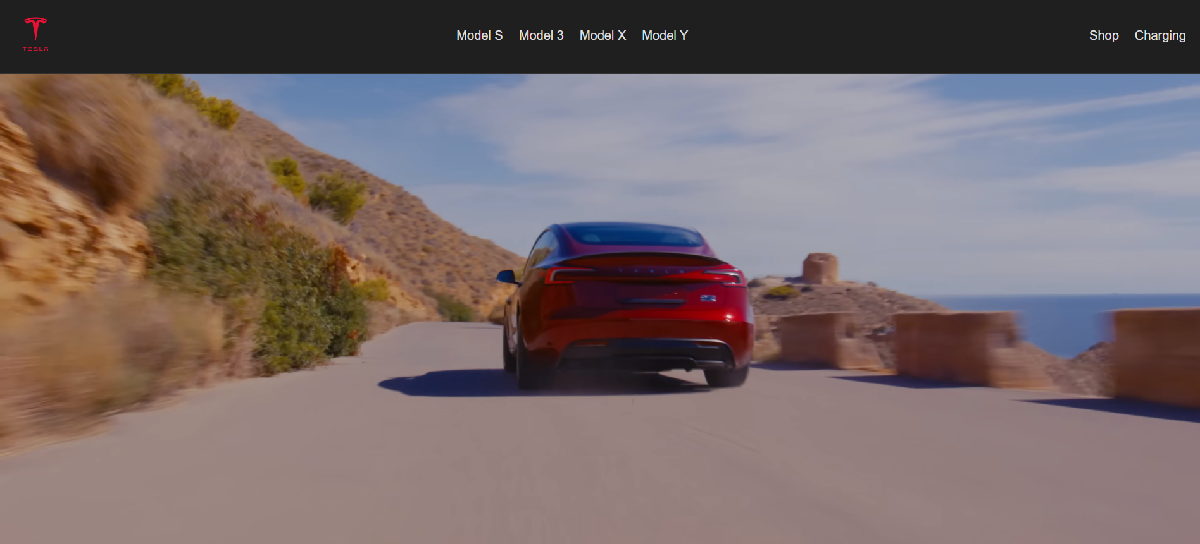

**This is a video**

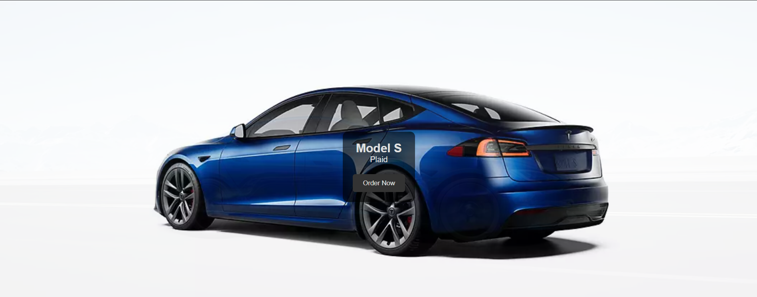

**This has slide animation**

